|  |  |
| --- | --- |
| Godox V860III Flash For Canon, Nikon, Sony, Fujifilm  Đèn flash Godox V860III For Canon, Nikon, Sony, Fujifilm... | Chính hãng  Godox V860III Godox V860III-2 Godox V860III-1 Godox V860III-3 | **Featured information:**  Large battery capacity  Godox X 2.4G wireless control system  The battery provides 480 flashes at full power  Cooldown time 1.5 seconds  Price : $ 155  **Specifications:**  Size  195 x 75 x 59 mm  Weight  530 g (with Battery)  Mount  Shoe  Off-Camera Terminal  2.5 mm  Bounce Head  Are not  Coverage  Full-Frame  20 - 200 mm  Swivel Head  Are not  Flash Duration  1/300 to 1/20000 second  Recycling time  About 1.5 seconds  GN index  60m at ISO 100 and flash angle 200mm |

**Overview:**

Godox V860III is a new version that Godox has just released, upgraded from the V860II version with many outstanding features. The lamp has good performance and is compatible with Canon, Fujifilm, Sony, Nikon, Olympus, Panasonic and Pentax cameras. This flash supports high-speed synchronization, flash exposure compensation, adding more features to enhance your photography.

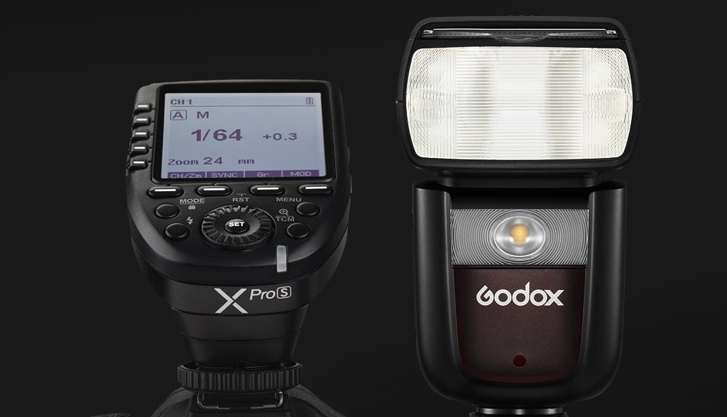

The light has many different flash modes that allow you to unleash your creativity such as TTL, Manual and Multi modes. Functions like HSS, FEC, FEB,... help you record every moment quickly and accurately. With the light head's zoom ability from 20mm to 200mm, users can adjust the light range easily. Whether photographing a wide scene or a small space, the V860III naturally illuminates the subject.

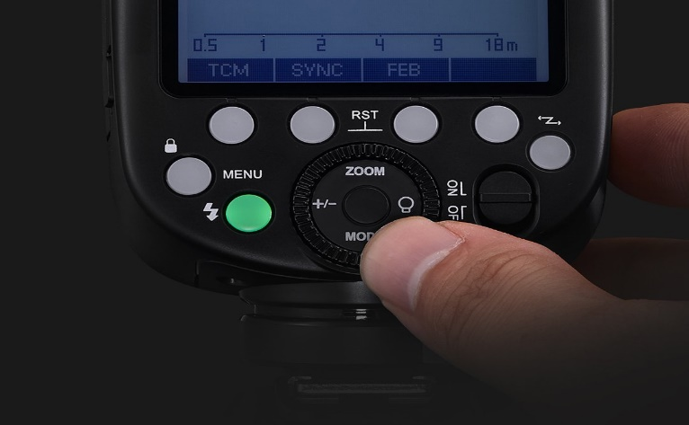

The Godox V860III is equipped with a quick lever to switch between TTL or Manual mode for quick, smooth shooting. A quick release lock is also integrated on the light to ensure the safety of the device during use with the camera. The lock's design also allows for easy and quick unlocking when inactive.

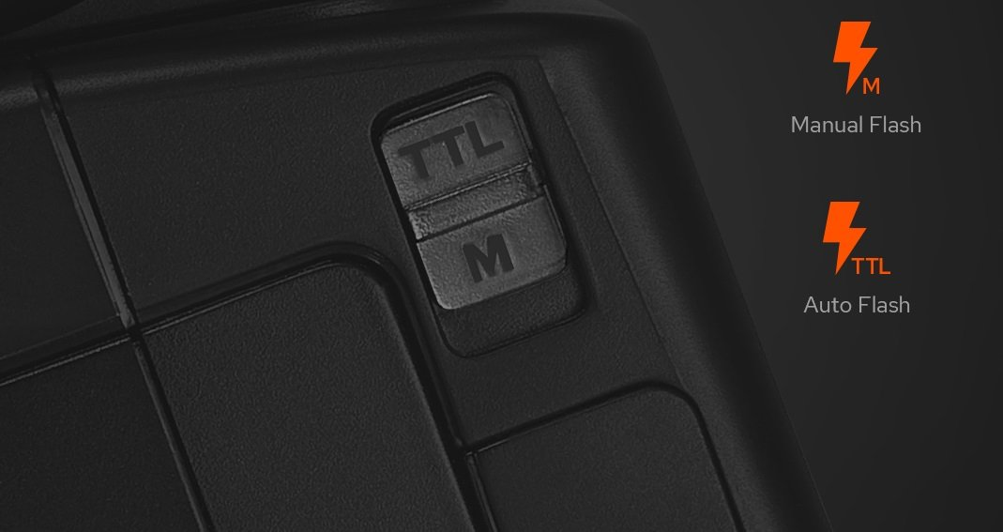

Godox V860III for Sony, Fujifilm, Nikon, Canon... uses a Li-on battery with upgraded battery capacity to support your photography better. Each full charge gives a maximum of 480 flashes with a recovery time of 1.5 seconds at maximum capacity.